# LAB -1

## HTML Introduction

### Code: -

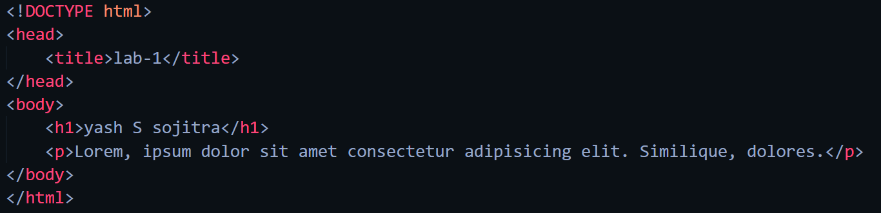

### Web-page display: -

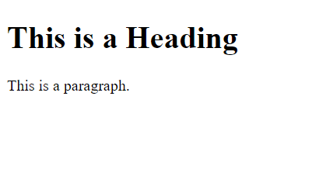 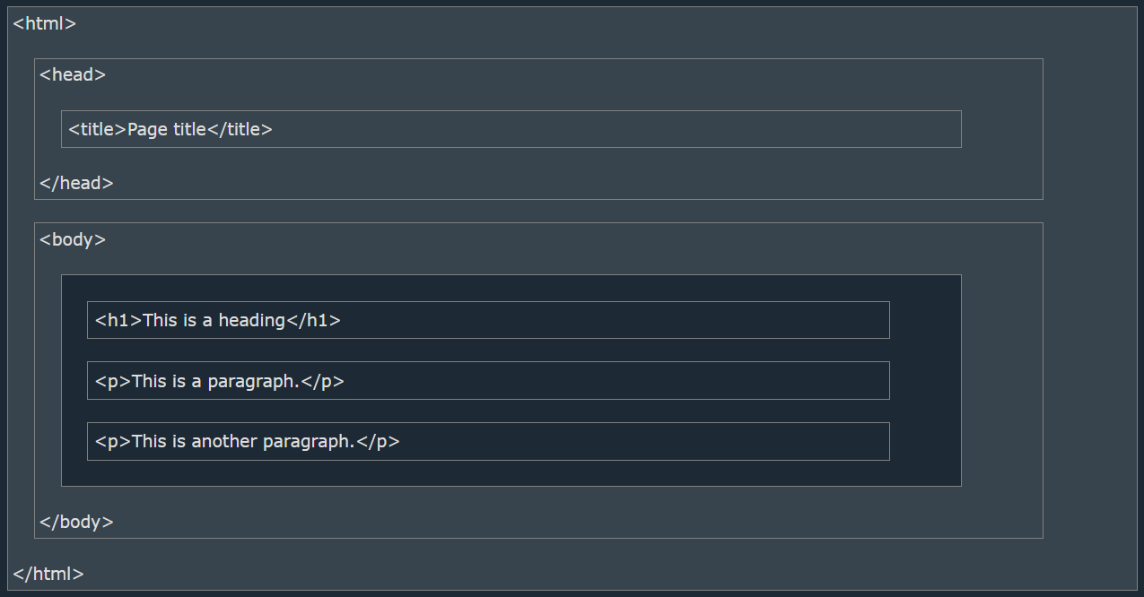

### Important points: -

* HTML stands for Hyper Text Markup Language
* HTML is the standard markup language for creating Web pages
* HTML describes the structure of a Web page
* HTML consists of a series of elements
* HTML elements tell the browser how to display the content
* HTML elements label pieces of content such as "this is a heading", "this is a paragraph", "this is a link", etc.
* The <!DOCTYPE html> declaration defines that this document is an HTML5 document
* The <html> element is the root element of an HTML page
* The <head> element contains meta information about the HTML page
* The <title> element specifies a title for the HTML page (which is shown in the browser's title bar or in the page's tab)
* The <body> element defines the document's body, and is a container for all the visible contents, such as headings, paragraphs, images, hyperlinks, tables, lists, etc.
* The <h1> element defines a large heading
* The <p> element defines a paragraph
* All HTML documents must start with a document type declaration: <!DOCTYPE html>.
* The HTML document itself begins with <html> and ends with </html>.
* The visible part of the HTML document is between <body> and </body>.
* The HTML document itself begins with <html> and ends with </html>.
* The visible part of the HTML document is between <body> and </body>.

## Basic HTML

### Code: -

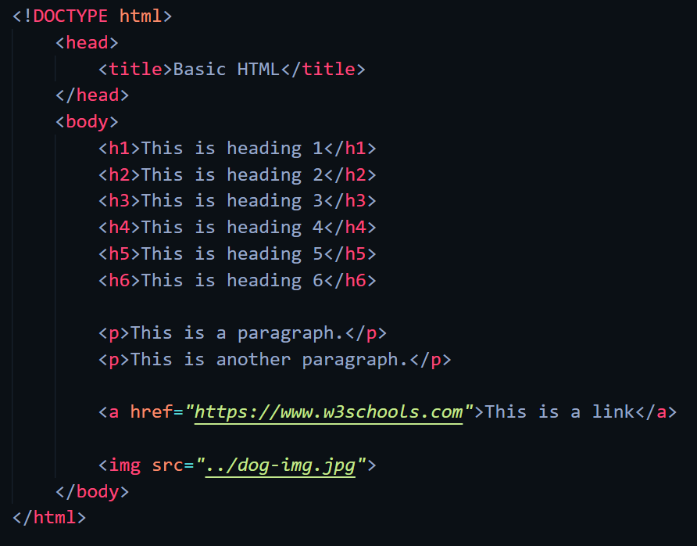

## Web-page display: -

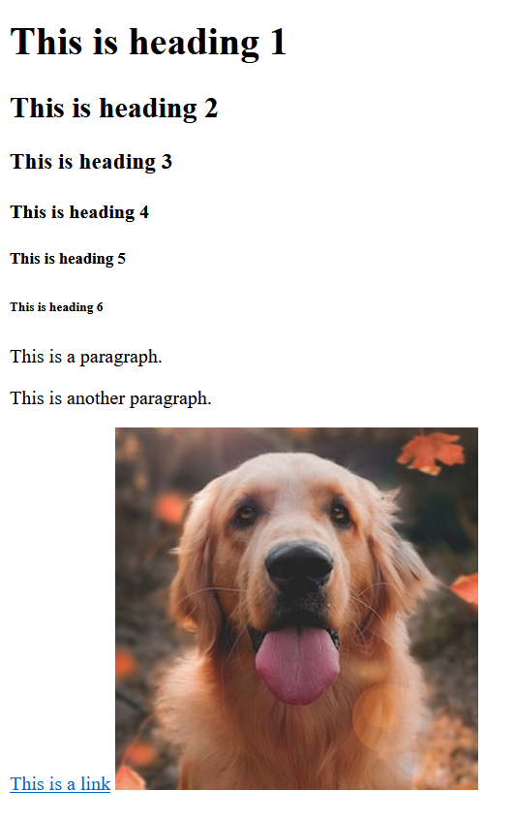

## Important Points: -

* HTML Headings are defined with <h1> to <h6> tags.
* <h1> defines the most important heading. <h6> defines the least important heading.
* HTML paragraphs are defined with the <p> tag.
* HTML links are defined with the <a> tag.
* The link's destination is specified in the href=”” attribute.
* Attributes are used to provide additional information about HTML elements.
* You will learn more about attributes in a later chapter.
* HTML images are defined with the <img> tag.
* The source file (src), alternative text (alt), width, and height are provided as attributes
* View HTML Source Code:
  + Right-click in an HTML page and select "View Page Source" (in Chrome) or "View Source" (in Edge), or similar in other browsers. This will open a window containing the HTML source code of the page.
* Inspect an HTML Element:
  + Right-click on an element (or a blank area), and choose "Inspect" or "Inspect Element" to see what elements are made up of (you will see both the HTML and the CSS). You can also edit the HTML or CSS on-the-fly in the Elements or Styles panel that opens.

## HTML Elements

## Code:

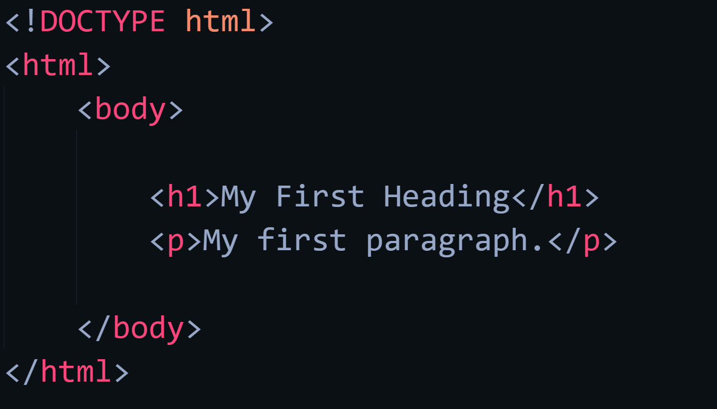 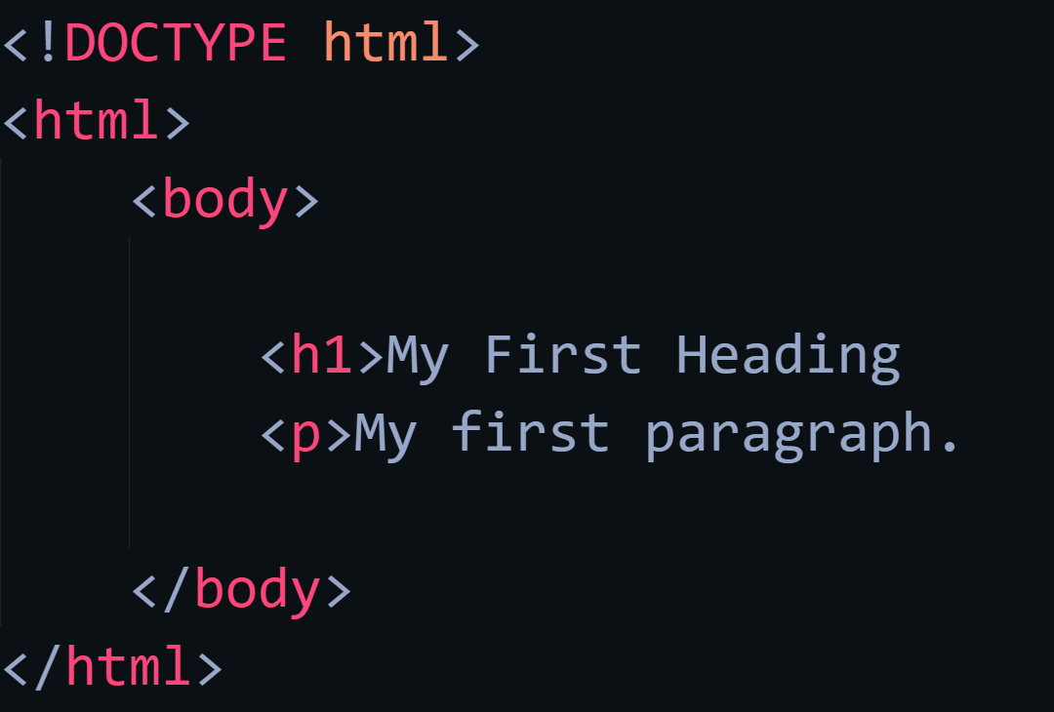

## Web-page Display: -

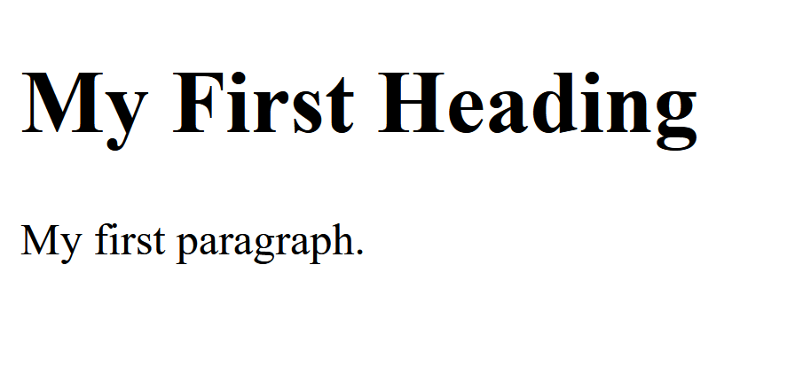 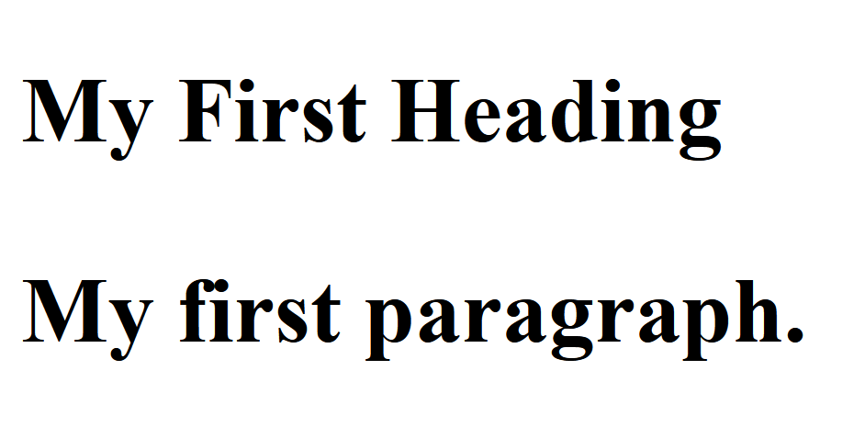

## Important Points: -

* HTML elements can be nested (this means that elements can contain other elements).
* All HTML documents consist of nested HTML elements.
* HTML tags are not case sensitive: <P> means the same as <p>.
* Example explained
  + The <html> element is the root element and it defines the whole HTML document.
  + It has a start tag <html> and an end tag </html>.
  + Then, inside the <html> element there is a <body> element.
  + The <body> element defines the document's body.
  + It has a start tag <body> and an end tag </body>.
  + Then, inside the <body> element there are two other elements: <h1> and <p>
* Never Skip the End Tag
  + Some HTML elements will display correctly, even if you forget the end tag(as shown in code two)
* Empty HTML Elements
  + HTML elements with no content are called empty elements.
  + The <br> tag defines a line break, and is an empty element without a closing tag.

## HTML Attributes

## Code: -

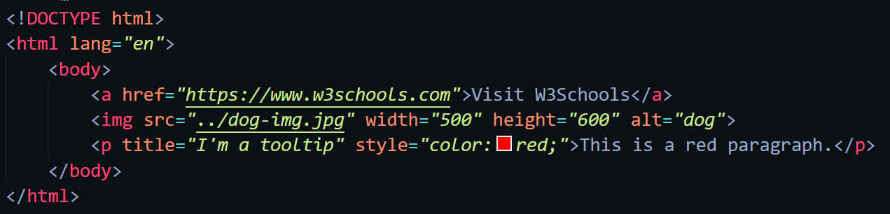

## Web-page display: -



## Important Points: -

* HTML Attributes
  + All HTML elements can have **attributes**
  + Attributes provide **additional information** about elements
  + Attributes are always specified in **the start tag**
  + Attributes usually come in name/value pairs like: **name="value"**
* Href Attribute
  + The <a> tag defines a hyperlink. The href attribute specifies the URL of the page the link goes to.
* Src Attribute
  + The <img> tag is used to embed an image in an HTML page. The src attribute specifies the path to the image to be displayed.
  + There are two ways to specify the URL in the src attribute:
    1. **Absolute URL** - Links to an external image that is hosted on another website. Example: src="https://www.w3schools.com/images/img_girl.jpg".
    2. **Relative URL** - Links to an image that is hosted within the website. Here, the URL does not include the domain name. If the URL begins without a slash, it will be relative to the current page. Example: src="img_girl.jpg". If the URL begins with a slash, it will be relative to the domain. Example: src="/images/img_girl.jpg".
* Width and height Attributes
  + The <img> tag should also contain the width and height attributes, which specify the width and height of the image (in pixels).
* The alt Attribute
  + The required alt attribute for the <img> tag specifies an alternate text for an image, if the image for some reason cannot be displayed. This can be due to a slow connection, or an error in the src attribute, or if the user uses a screen reader.
* The Style Attribute
  + The style attribute is used to add styles to an element, such as color, font, size, and more.
* The lang Attribute
  + You should always include the lang attribute inside the <html> tag, to declare the language of the Web page. This is meant to assist search engines and browsers.
  + Country codes can also be added to the language code in the lang attribute. So, the first two characters define the language of the HTML page, and the last two characters define the country.
* The Title Attribute
  + The title attribute defines some extra information about an element.
  + The value of the title attribute will be displayed as a tooltip when you mouse over the element

## HTML Headings

## Code: -

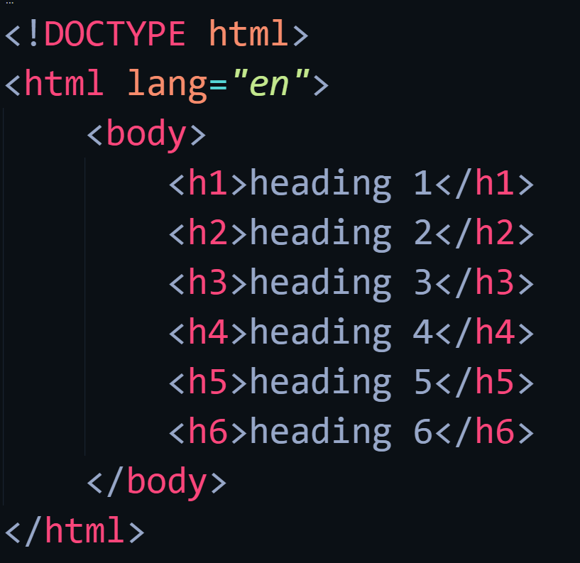

## Web-page display: -

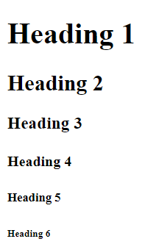

## Important Points: -

* + HTML headings are titles or subtitles that you want to display on a webpage.
  + HTML headings are defined with the <h1> to <h6> tags.
  + <h1> defines the most important heading. <h6> defines the least important heading.
  + Search engines use the headings to index the structure and content of your web pages.
  + Users often skim a page by its headings. It is important to use headings to show the document structure.
  + <h1> headings should be used for main headings, followed by <h2> headings, then the less important <h3>, and so on.
  + Each HTML heading has a default size. However, you can specify the size for any heading with the style attribute, using the CSS font-size property

## HTML Paragraphs

## Code: -

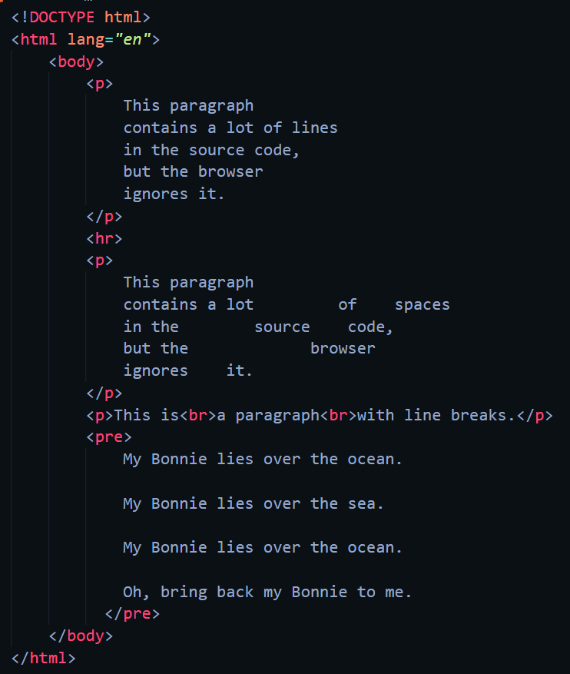

## Web-page Display: -

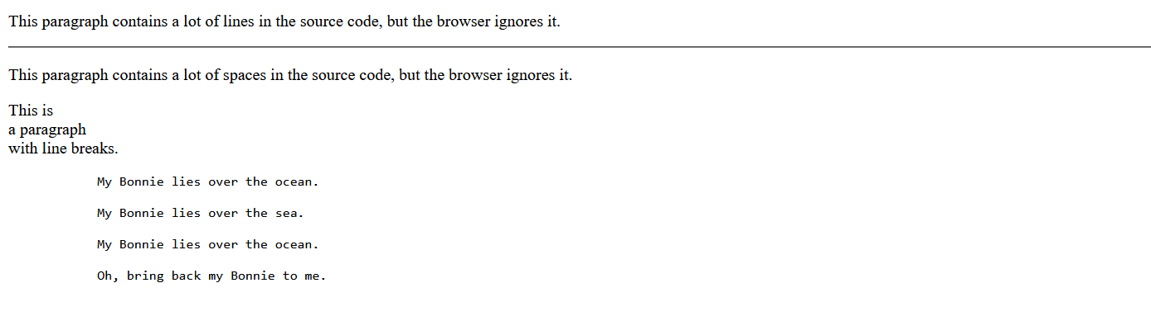

## Important Points: -

* The HTML <p> element defines a paragraph.
* A paragraph always starts on a new line, and browsers automatically add some white space (a margin) before and after a paragraph.
* The browser will automatically remove any extra spaces and lines when the page is displayed.
* The <hr> tag defines a thematic break in an HTML page, and is most often displayed as a horizontal rule.
* The <hr> element is used to separate content (or define a change) in an HTML page.
* The <hr> tag is an empty tag, which means that it has no end tag.
* The HTML <br> element defines a line break.
* Use <br> if you want a line break (a new line) without starting a new paragraph.
* The <br> tag is an empty tag, which means that it has no end tag.
* The HTML <pre> element defines preformatted text.
* The text inside a <pre> element is displayed in a fixed-width font (usually Courier), and it preserves both spaces and line breaks

## HTML Styles

## Code: -

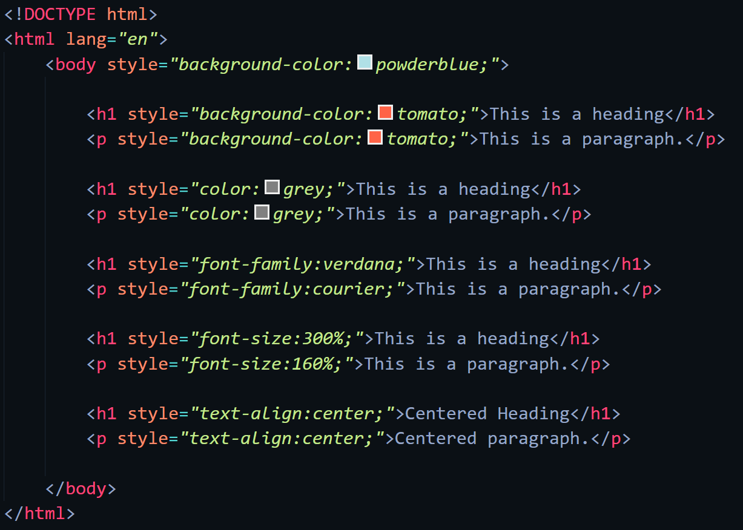

## Web-page Display: -

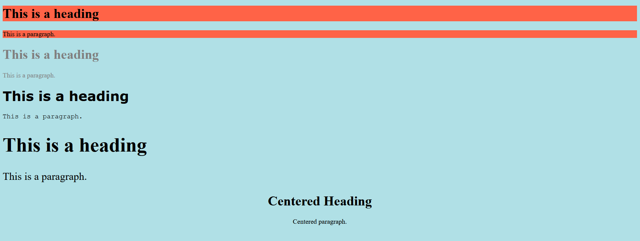

## Important Points: -

* Setting the style of an HTML element, can be done with the style attribute.
* The HTML style attribute has the following syntax
  + < tagname style="property:value;" >
* The CSS background-color property defines the background color for an HTML element
* The CSS color property defines the text color for an HTML element
* The CSS font-family property defines the font to be used for an HTML element
* The CSS font-size property defines the text size for an HTML element
* The CSS text-align property defines the horizontal text alignment for an HTML element

# LAB -2

## HTML Text Formatting

## Code: -

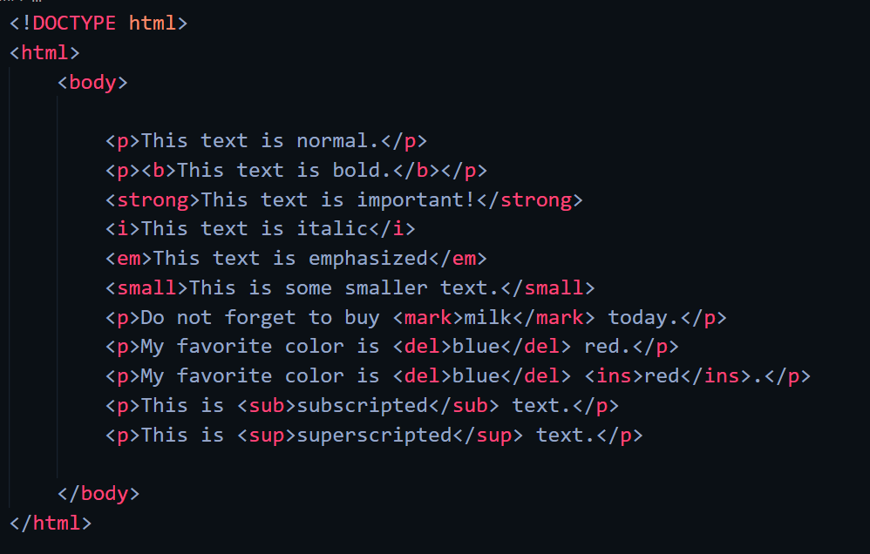

## Web-page display: -

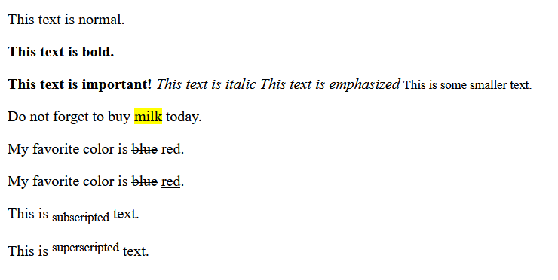

## Important Points: -

* The HTML <b> element defines bold text, without any extra importance.
* The HTML <strong> element defines text with strong importance. The content inside is typically displayed in bold.
* The HTML <i> element defines a part of text in an alternate voice or mood. The content inside is typically displayed in italic.
* Tip: The <i> tag is often used to indicate a technical term, a phrase from another language, a thought, a ship name, etc.
* The HTML <em> element defines emphasized text. The content inside is typically displayed in italic.
* Tip: A screen reader will pronounce the words in <em> with an emphasis, using verbal stress.
* The HTML <small> element defines smaller text
* The HTML <mark> element defines text that should be marked or highlighted.
* The HTML <del> element defines text that has been deleted from a document. Browsers will usually strike a line through deleted text.
* The HTML <ins> element defines a text that has been inserted into a document. Browsers will usually underline inserted text.
* The HTML <sub> element defines subscript text. Subscript text appears half a character below the normal line, and is sometimes rendered in a smaller font. Subscript text can be used for chemical formulas, like H2O.
* The HTML <sup> element defines superscript text. Superscript text appears half a character above the normal line, and is sometimes rendered in a smaller font. Superscript text can be used for footnotes, like WWW[1].

## HTML Quotations

## Code: -

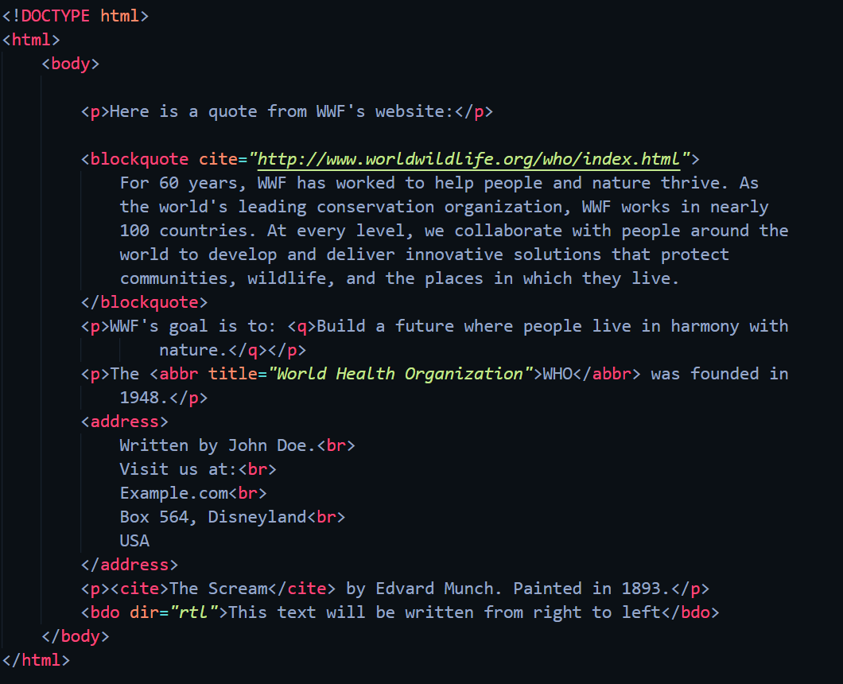

## Web-page Display: -

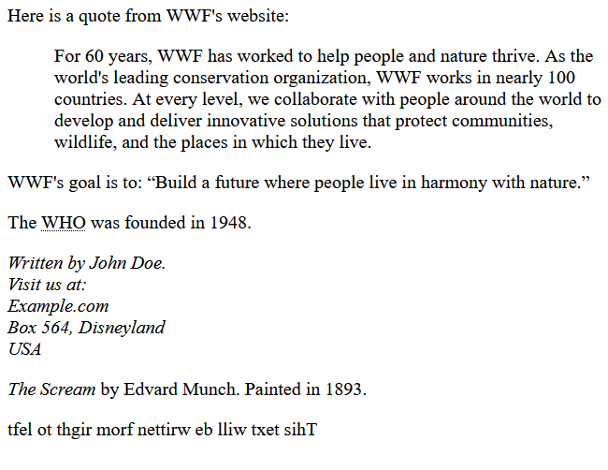

## Important Points: -

* HTML <blockquote> for Quotations
  + The HTML <blockquote> element defines a section that is quoted from another source.
  + Browsers usually indent <blockquote> elements.
* HTML <q> for Short Quotations
  + The HTML <q> tag defines a short quotation.
  + Browsers normally insert quotation marks around the quotation.
* HTML <abbr> for Abbreviations
  + The HTML <abbr> tag defines an abbreviation or an acronym, like "HTML", "CSS", "Mr.", "Dr.", "ASAP", "ATM".
  + Marking abbreviations can give useful information to browsers, translation systems and search-engines.
  + Tip: Use the global title attribute to show the description for the abbreviation/acronym when you mouse over the element.
* HTML <address> for Contact Information
  + The HTML <address> tag defines the contact information for the author/owner of a document or an article.
  + The contact information can be an email address, URL, physical address, phone number, social media handle, etc.
  + The text in the <address> element usually renders in italic, and browsers will always add a line break before and after the <address> element.
* HTML <cite> for Work Title
  + The HTML <cite> tag defines the title of a creative work (e.g. a book, a poem, a song, a movie, a painting, a sculpture, etc.).
  + Note: A person's name is not the title of a work.
  + The text in the <cite> element usually renders in italic.
* HTML <bdo> for Bi-Directional Override
  + BDO stands for Bi-Directional Override.
  + The HTML <bdo> tag is used to override the current text direction

## HTML Comments

## Code: -

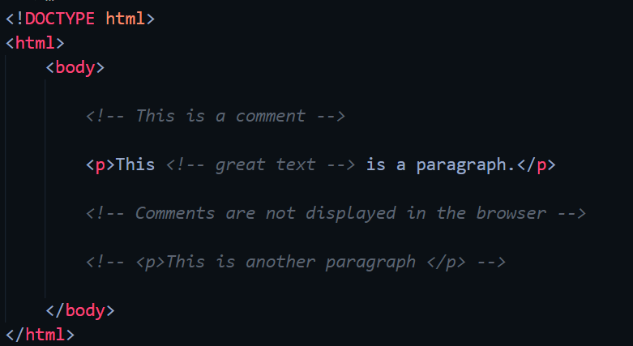

## Web-page Display: -



## Important Points: -

* Notice that there is an exclamation point (!) in the start tag, but not in the end tag.
* Note: Comments are not displayed by the browser, but they can help document your HTML source code.
* With comments you can place notifications and reminders in your HTML code.
* Comments can be used to hide content.
* This can be helpful if you hide content temporarily:
* You can also hide more than one line. Everything between the <!-- and the --> will be hidden from the display.
* Comments are also great for debugging HTML, because you can comment out HTML lines of code, one at a time, to search for errors.
* Comments can be used to hide parts in the middle of the HTML code.

## HTML Colors

## Code: -

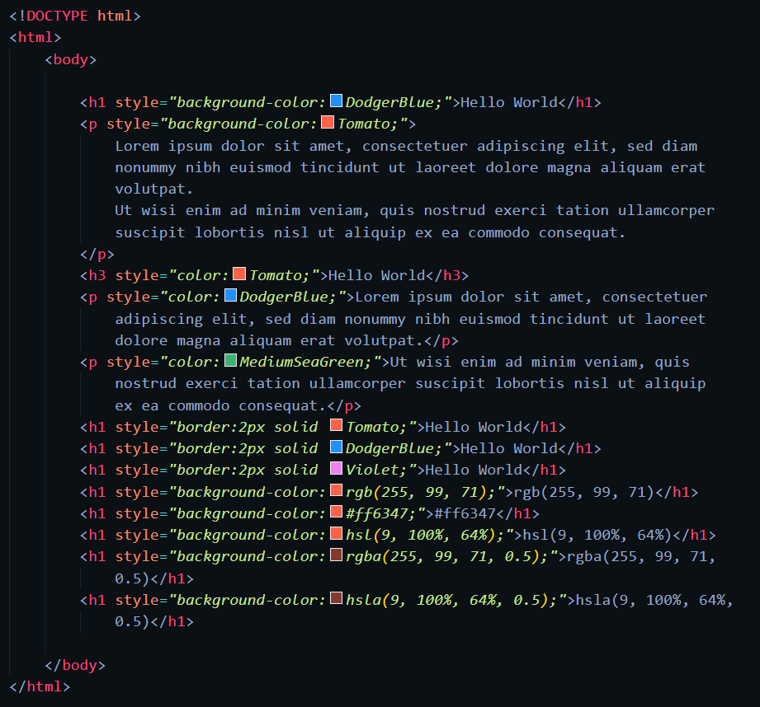

## Web-page Display: -

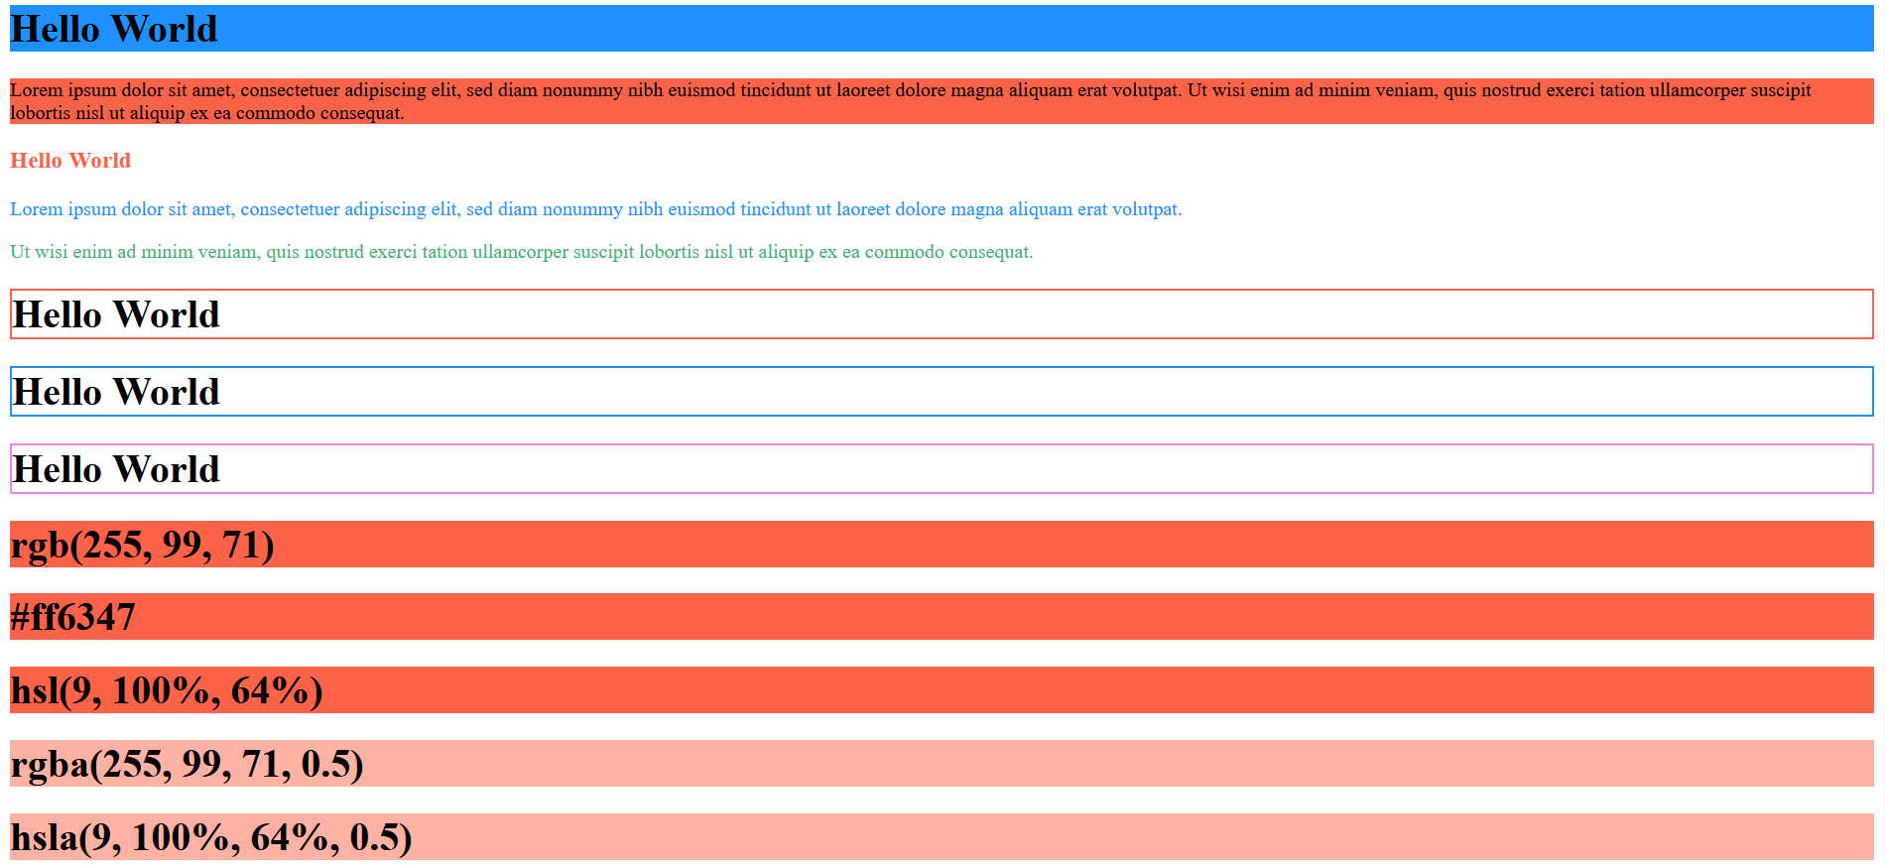

## Important Points: -

* Colors
  + HTML colors are specified with predefined color names, or with RGB, HEX, HSL, RGBA, or HSLA values.
  + Using colors to set background color, font color, border color of html elements.
* HTML RGB and RGBA Colors
  + An RGB color value represents RED, GREEN, and BLUE light sources.
  + An RGBA color value is an extension of RGB with an Alpha channel (opacity)
  + ***rgb(red, green, blue)***
  + Each parameter (red, green, and blue) defines the intensity of the color with a value between 0 and 255.
  + This means that there are 256 x 256 x 256 = 16777216 possible colors!
  + Shades of grey are often defined using equal values for all three parameters
  + RGBA color values are an extension of RGB color values with an Alpha channel - which specifies the opacity for a color.
  + An RGBA color value is specified with:

***rgba(red, green, blue, alpha)***

* + The alpha parameter is a number between 0.0 (fully transparent) and 1.0 (not ransparent at all)
* HEX Color Values
  + In HTML, a color can be specified using a hexadecimal value in the form:

***#rrggbb***

* + Where ‘rr’ (red), ‘gg’ (green) and ‘bb’ (blue) are hexadecimal values between 00 and ff (same as decimal 0-255).
  + To display black, set all color parameters to 00, like this: #000000.
  + To display white, set all color parameters to ff, like this: #ffffff.
* HTML HSL and HSLA Colors
  + HSL stands for hue, saturation, and lightness.
  + HSLA color values are an extension of HSL with an Alpha channel (opacity).
  + In HTML, a color can be specified using hue, saturation, and lightness (HSL) in the form:

***hsl(hue, saturation, lightness)***

* + Hue is a degree on the color wheel from 0 to 360. 0 is red, 120 is green, and 240 is blue.
  + Saturation is a percentage value. 0% means a shade of gray, and 100% is the full color.
  + Lightness is also a percentage value. 0% is black, and 100% is white.
  + Saturation
    - Saturation can be described as the intensity of a color.
    - 100% is pure color, no shades of gray.
    - 50% is 50% gray, but you can still see the color.
    - 0% is completely gray; you can no longer see the color.
  + Lightness
    - The lightness of a color can be described as how much light you want to give the color, where 0% means no light (black), 50% means 50% light (neither dark nor light), and 100% means full lightness (white).
  + HSLA color values are an extension of HSL color values, with an Alpha channel - which specifies the opacity for a color.
  + An HSLA color value is specified with:

***hsla(hue, saturation, lightness, alpha)***

* + The alpha parameter is a number between 0.0 (fully transparent) and 1.0 (not transparent at all).

## HTML Styles – CSS

## Code: -

Inline CSS Internal CSS

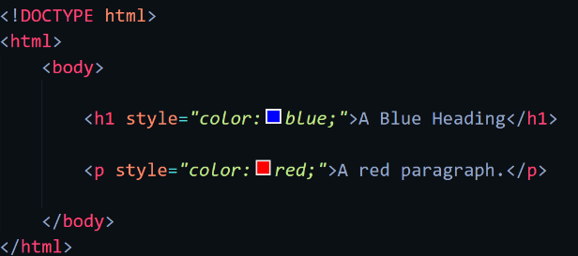 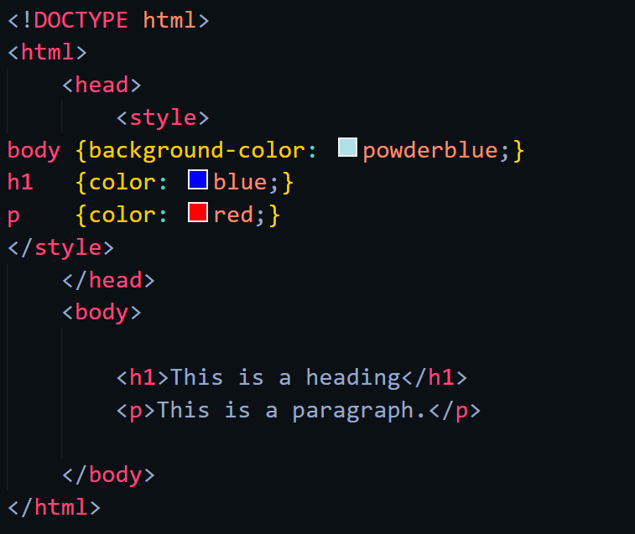

External CSS

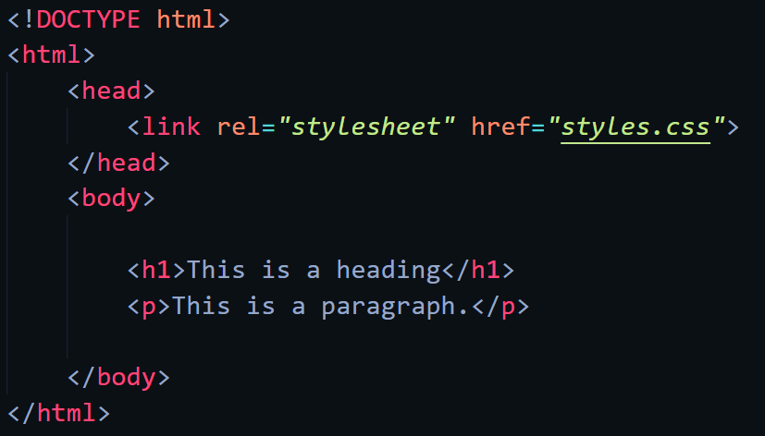 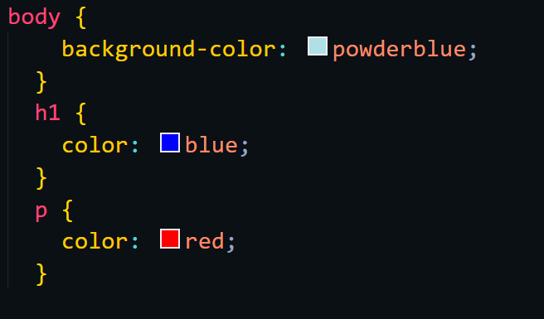

Some CSS properties

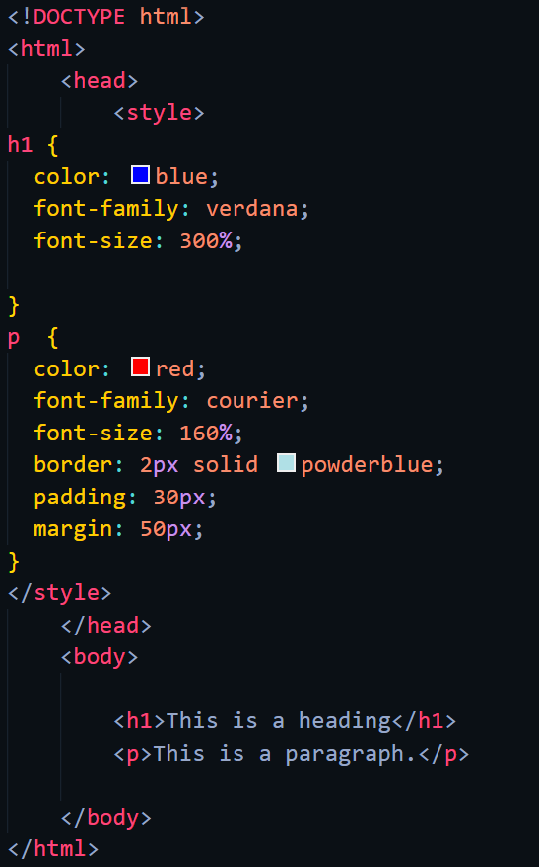

## Web-page Display: -

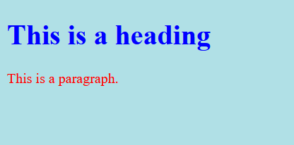

## Important Points: -

* + What is CSS?
    - Cascading Style Sheets (CSS) is used to format the layout of a webpage.
    - With CSS, you can control the color, font, the size of text, the spacing between elements, how elements are positioned and laid out, what background images or background colors are to be used, different displays for different devices and screen sizes, and much more!
    - CSS can be added to HTML documents in 3 ways:
      * Inline - by using the style attribute inside HTML element.
      * Internal - by using a <style> element in the <head> section.
      * External - by using a <link> element to link to an external CSS file.
  + Inline CSS
    - An inline CSS is used to apply a unique style to a single HTML element.
    - An inline CSS uses the style attribute of an HTML element.
    - The following example sets the text color of the <h1> element to blue, and the text color of the <p> element to red
  + Internal CSS
    - An internal CSS is used to define a style for a single HTML page.
    - An internal CSS is defined in the <head> section of an HTML page, within a <style> element.
    - The following example sets the text color of ALL the <h1> elements (on that page) to blue, and the text color of ALL the <p> elements to red. In addition, the page will be displayed with a "powderblue" background color.
  + External CSS
    - An external style sheet is used to define the style for many HTML pages.
    - To use an external style sheet, add a link to it in the <head> section of each HTML page
    - The external style sheet can be written in any text editor. The file must not contain any HTML code, and must be saved with a .css extension.
  + CSS Colors, Fonts and Sizes
    - The CSS color property defines the text color to be used.
    - The CSS font-family property defines the font to be used.
    - The CSS font-size property defines the text size to be used.
  + CSS Border
    - The CSS border property defines a border around an HTML element.
    - Tip: You can define a border for nearly all HTML elements.
  + CSS Padding
    - The CSS padding property defines a padding (space) between the text and the border.
  + CSS Margin
    - The CSS margin property defines a margin (space) outside the border.

## HTML Links

## Code: -

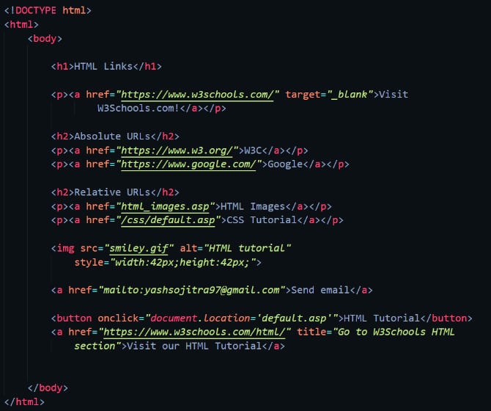 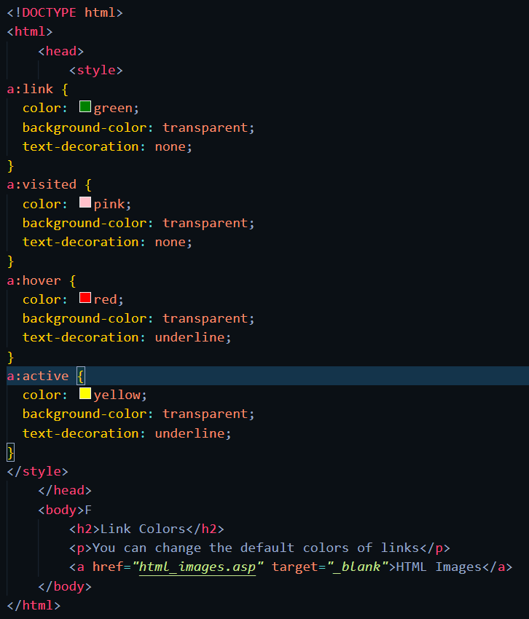

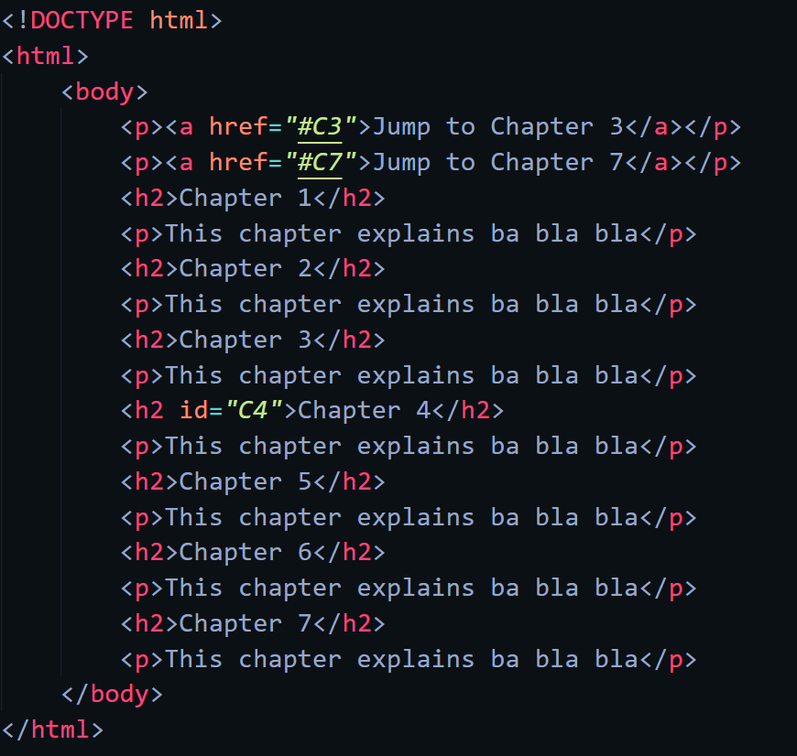

## Web-page Display: -

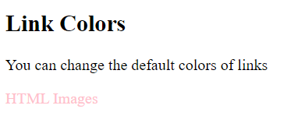

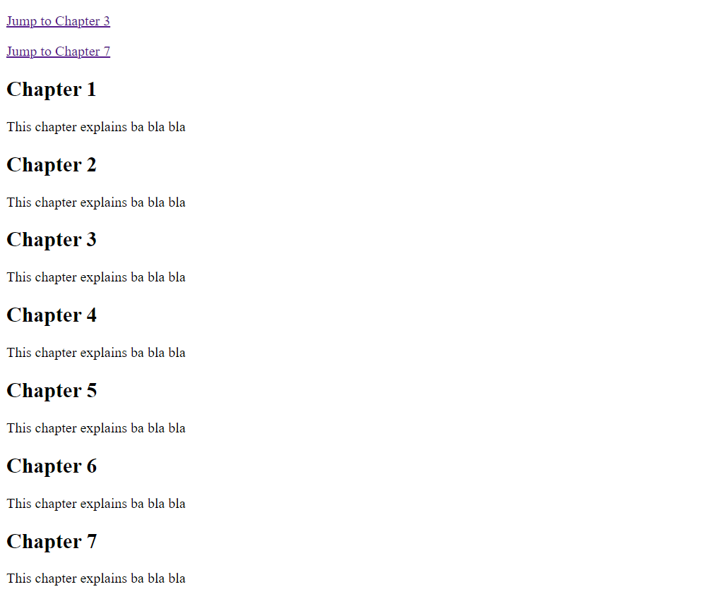

## Important Points: -

* HTML Links – Hyperlinks
  + HTML links are hyperlinks.
  + You can click on a link and jump to another document.
  + When you move the mouse over a link, the mouse arrow will turn into a little hand.
* HTML Links – Syntax
  + The HTML <a> tag defines a hyperlink. It has the following syntax:

***<a href="url">link text</a>***

* + The most important attribute of the <a> element is the href attribute, which indicates the link's destination.
  + The link text is the part that will be visible to the reader.
  + Clicking on the link text, will send the reader to the specified URL address.
* HTML Links - The target Attribute
  + By default, the linked page will be displayed in the current browser window. To change this, you must specify another target for the link.
  + The target attribute specifies where to open the linked document.
  + The target attribute can have one of the following values:
    - * _self - Default. Opens the document in the same window/tab as it was clicked
      * _blank - Opens the document in a new window or tab
      * _parent - Opens the document in the parent frame
      * _top - Opens the document in the full body of the window
* Absolute URLs vs. Relative URLs
  + Both examples above are using an absolute URL (a full web address) in the href attribute.
  + A local link (a link to a page within the same website) is specified with a relative URL (without the "https://www" part)
* HTML Links - Use an Image as a Link
  + To use an image as a link, just put the <img> tag inside the <a> tag
* Link to an Email Address
  + Use mailto: inside the href attribute to create a link that opens the user's email program (to let them send a new email)
* Button as a Link
  + To use an HTML button as a link, you have to add some JavaScript code.
  + JavaScript allows you to specify what happens at certain events, such as a click of a button.
* Link Titles
  + The title attribute specifies extra information about an element. The information is most often shown as a tooltip text when the mouse moves over the element.
* HTML Link Colors
  + By default, a link will appear like this (in all browsers):
    - * An unvisited link is underlined and blue
      * A visited link is underlined and purple
      * An active link is underlined and red
  + A link can also be styled as a button, by using CSS.
* Bookmarks in HTML
  + Bookmarks can be useful if a web page is very long.
  + To create a bookmark - first create the bookmark, then add a link to it.
  + When the link is clicked, the page will scroll down or up to the location with the bookmark.
  + First, use the id attribute to create a bookmark:

<h2 id="C4">Chapter 4</h2>

* + Then, add a link to the bookmark ("Jump to Chapter 4"), from within the same page:

<a href="#C4">Jump to Chapter 4</a>

* + You can also add a link to a bookmark on another page

## HTML Images

## Code: -

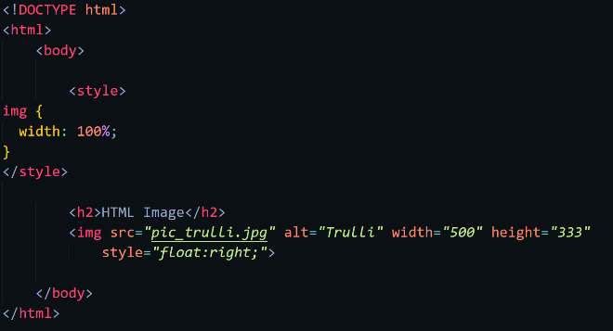 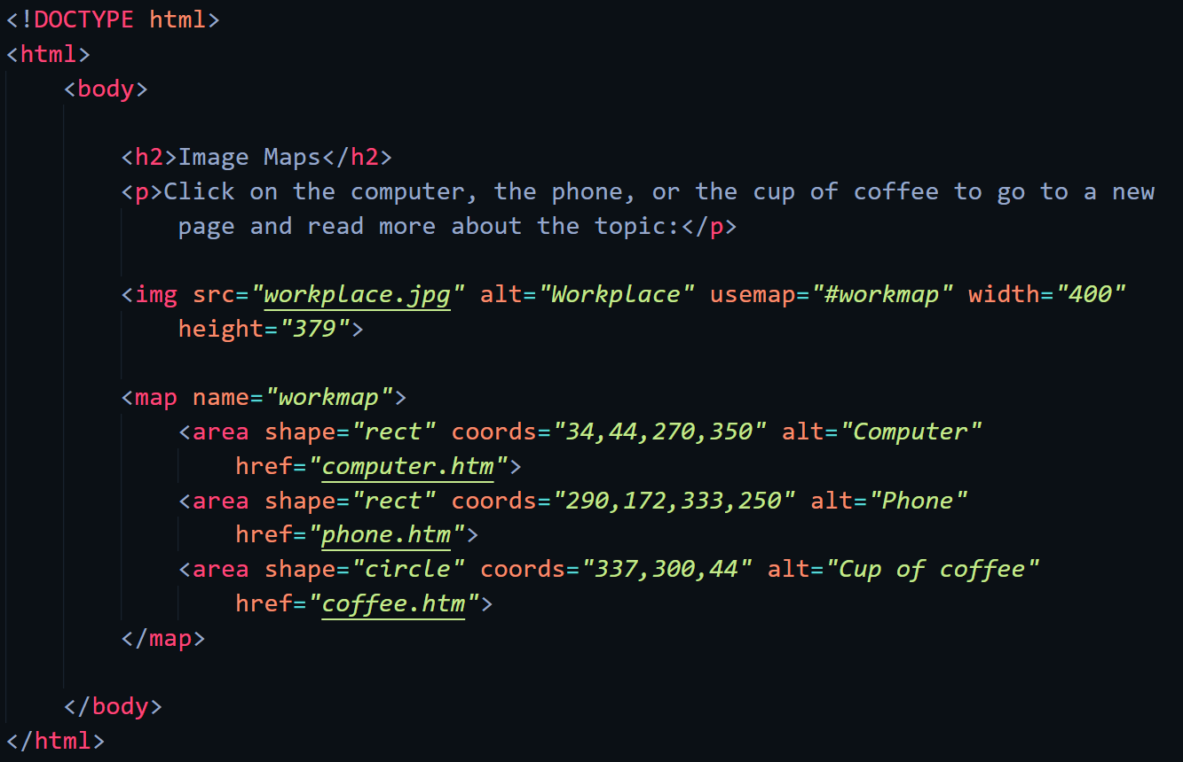

## Web-page Display: -

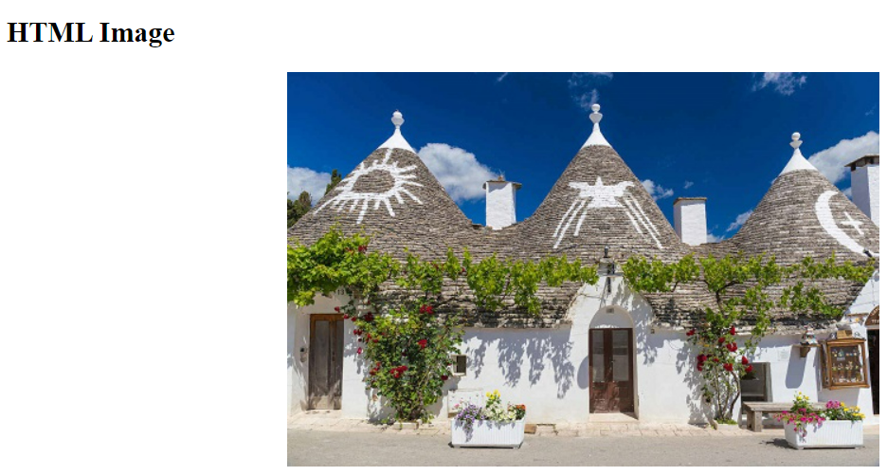

## Important Points: -

HTML Favicon

Code: -

Web-page Display: -

Important Points: -

HTML Page Title

Code: -

Web-page Display: -

Important Points: -

HTML Styles – CSS

Code: -

Web-page Display: -

Important Points: -